Early Childhood Education and Out-of-School Time Workforce Recruiting and Retention
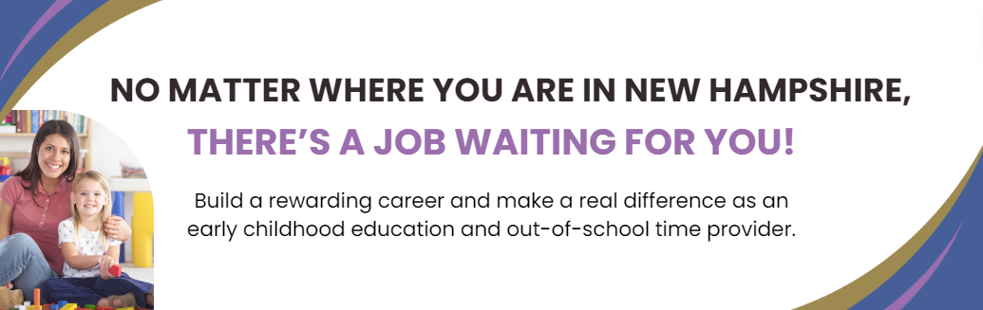
The early years of a child's life are foundational, laying the groundwork for their cognitive, emotional, and social growth. Those who embark on a career in early childhood education and out-of-school time play a pivotal role in creating a nurturing and stimulating environment where New Hampshire’s children can flourish. Explore the resources below for information tailored for job seekers and programs looking to hire.
Job Seekers
Program Administrators

Looking For a Career in Early Childhood Education and Out-of-School Time?
No matter where you are in New Hampshire, there is a job for you! New Hampshire children and families need you to help shape the future of our communities. Become an early childhood education or out-of-school time provider and make an impact on the next generation!
Why Choose a Career in Early Childhood Education and Out-of-school Time?
If you're looking for a career that's not just a job, consider working in the early childhood education and out-of-school time field, where each day is a chance to make a positive mark on the hearts and minds of New Hampshire’s littlest learners.
Working in early childhood education or out-of-school time offers many benefits, including:
- Vacation, sick leave, and medical and dental insurance
- Free professional development
- Flexible work hours
- A clear career trajectory
- Reduced cost child care
Finding Job Opportunities
There are a variety of online resources where you can look for jobs and learn helpful tips for landing a job. Explore the following sites below to get a head start on the job search process.

New Hampshire Employment Security job fairs: https://www.unemploymentbenefits.nh.gov/node/1171
- NH Connections child care job board: https://www.nh-connections.org/providers/job-board/
- Child Care Aware of NH job board: https://www.nh-connections.org/providers/job-board/early-childhood-and-out-of-school-time-employment-opportunities/
- Upper Valley Early Care and Education Association job board: https://eceauv.org/careers/

Pathway to an Early Childhood Education and Out-of-School Time Career
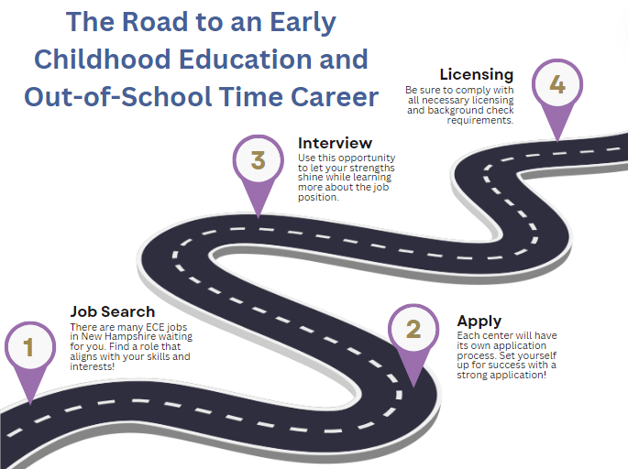
If you are interested in a career in early childhood education and out-of-school time, familiarize yourself with the licensing requirements and regulations in New Hampshire. This typically involves completing training courses related to child development, safety, and health. Job candidates may also need to undergo background checks and provide documentation of their qualifications. For detailed guidance and support throughout this process, individuals are encouraged to reach out to the NH Department of Health and Human Services (DHHS) Child Care Licensing Unit via their website: https://www.dhhs.nh.gov/programs-services/childcare-parenting-childbirth/child-care-licensing or email: CCLUoffice@dhhs.nh.gov.
Consider Opening a Family Child Care
Opening a family child care (FCC) out of your home provides the chance to create a warm environment for children, fostering a sense of security and comfort. For more information on starting a family child care, contact the Community Development Finance Authority at 603-226-2170.
Visit the following sites to explore business support opportunities:
- United Way of Greater Nashua FCC training program: [developer note: final website link will be added when PCG receives it from United Way]
- Child Care Accelerate, an 8-week business support program: https://www.childcareaccelerate.com/
Early Childhood Education is a Perfect Fit for Veterans and Military Families
Looking to continue your service after leaving the military? Consider a career in early childhood education and out-of-school time! The skills you’ve developed in the military can be a benefit to early childhood environments – patience, organization skills, teamwork, and leadership are all necessary to succeed in early childhood education. Offer a critical service to your community by working as a child care provider at a center or starting your own family child care out of your own home!
For more information on transitioning into early childhood education and out-of-school time as a veteran, visit the Division of Community-Based Military Programs website: https://www.dmavs.nh.gov/community-based-military-programs.
Early Childhood Education and Out-of-School Time Jobs for High School and College Students
High school and college students can play a pivotal role in shaping young minds, fostering creativity, and promoting a positive learning environment. A job in early childhood education and out-of-school time offers not only a fulfilling opportunity to make a difference in a child's life but also serves as a foundation for future careers in education, social services, and more.

Job Opportunities
Summer Camps. Spend your summer diving into a dynamic environment where enthusiasm and creativity are celebrated and create lifelong connections with fellow staff members and campers. Through organizing and leading engaging activities, you'll hone leadership, teamwork, and problem-solving skills that can be applied to any career.
Part-time Early Childhood Education or Out-of-School Time. Flexible, part-time hours allow you to balance a career with academic responsibilities. Choose part-time early childhood education and out-of-school time positions to make a positive impact on young lives while striking the perfect balance between education and hands-on experience.
Family Child Care Assistant. Collaborate closely with experienced caregivers to implement engaging activities, foster positive relationships, and ensure the well-being of each child. This role provides a unique opportunity for high school and college students to gain hands-on experience in early childhood education while accommodating academic commitments.

Learning Opportunities
VLACS. The Virtual Learning Academy Charter School offers free online courses for New Hampshire high school-aged residents. Interested high schoolers can take courses related to early childhood education and learn about important topics such as child development and crafting curriculum. Participants can earn a digital badge upon course completion. Additionally, the courses offer 0.5 high school credits. Learn more about the VLACS Early Childhood course here: https://vlacs.org/courses/early-childhood-education-1b/.

Looking to Hire Qualified, Energetic Educators?
Assembling a team of qualified and committed professionals is crucial for creating an environment conducive to learning and positive child outcomes. A diverse team brings a variety of skills and perspectives and contributes to the program's success. Invest in the retention of dedicated staff and create a positive impact on New Hampshire’s youngest generation!

Workforce Recruiting Guide
It is well documented that children enrolled in high quality early education programs experience positive life outcomes. Staff stability is a critical factor in establishing a quality program. Recruiting for your early childhood or out-of-school time program can seem overwhelming, but following these tips and guidelines can make the process a lot easier.

Expand recruiting channels
If you are struggling to recruit qualified individuals, consider the following pipelines to fill vacant positions:
Local High Schools. This is an excellent way to reach young people who are beginning to explore career opportunities.
Local Older Adult Organizations. Explore opportunities to recruit retired individuals who may be interested in returning to the workforce to supplement their income.
Local Early Childhood Education Organizations. Contact local early childhood education organizations or associations and inquire about any job boards they may offer or networking events they host where you can meet potential candidates.
Community Centers and Libraries. Contact community centers, libraries, and other local gathering places. Many of these organizations often have bulletin boards where you can advertise your job openings.
Staff Referrals. One of the easiest ways to promote your job opening is to enlist the help of your current staff. It is quite possible that they have contacts who may be interested and a good fit for your available positions.
Job Fairs or Career Events. A traditional way to recruit is to participate in local job fairs or career events that focus on child care or general education. This allows you an opportunity to meet individuals who have a strong interest in the early childhood education and out-of-school time field. New Hampshire maintains an updated list of upcoming job fairs on the Employment Security website: https://business.nh.gov/nhesjobfair.

Know how to sell your program to candidates
In a job market with plenty of competition, it is crucial to be able to highlight the benefits of working at your program to attract the most qualified staff. While your program may not be able to offer the highest hourly rates, consider the benefits your program may offer:
- Offering paid holidays throughout the year, meaning a staff is earning income on these days and not working
- Vacation/sick time accrual
- Medical or dental coverage, even if accessed through the federal health insurance option
- Retirement savings. This may be an employer matching program or an initial deposit to a retirement savings account as a way to get the account started.
- A paid membership to a professional development organization so employees can access trainings throughout the year
- Reduced cost child care
- Let’s imagine the child care program offers a 30% discount. For full-time child care costing around $940 a month, this would be a monthly savings of $282 (value: $3,384 annually)
- Free professional development. Some in-state programs allow an early childhood education employee a Child Development Associate (CDA) credential or bachelor’s degree free of charge.
- Clear career path/growth trajectory
- A staff member may begin as an assistant teacher and, depending on their career goals, can work to become a director or business owner.
10. Program Bonuses

Consider implementing these benefits into your program and be sure to highlight them during the application and interviewing process to attract candidates!

For more information, visit our Workforce Recruiting Guide: [Developer note: placeholder for guide]

Improve Your Online Recruiting Presence
Maintaining an active presence on online job posting websites like Indeed, LinkedIn, and ZipRecruiter is crucial for early childhood education and out-of-school time programs to effectively connect with potential candidates in today's digital age. These platforms offer a broad reach, ensuring that job opportunities within early childhood education programs reach a diverse pool of qualified applicants. These platforms also facilitate quicker and more convenient communication among employers and job seekers, fostering a more dynamic and responsive hiring process.
Explore the following hiring guides to learn how to optimize your online recruiting presence:
- Indeed’s Hiring Guide: https://www.indeed.com/hire/resources/howtohub/hiring-guide-using-employer-tools
- Smart Recruiter’s Hiring Success Glossary: https://www.smartrecruiters.com/resources/glossary/job-posting/
- Workable’s Ultimate Guide to Job Posting: https://resources.workable.com/tutorial/job-posting-guide
Retaining Staff
Staff retention in the early childhood education and out-of-school time workforce is crucial for ensuring the consistent and high-quality care of children. Building a stable and experienced team not only fosters a nurturing environment but also contributes to the overall development and well-being of the children in their care.

Wellness
The nature of early childhood education work demands attention, empathy, and energy, making it essential to prioritize the well-being of those responsible for the care and development of children. Recognizing and addressing the mental health needs of early childhood education staff is an investment in the long-term success and effectiveness of the early childhood setting, ultimately ensuring a nurturing and stable environment for the children in their care.
Explore dozens of free and affordable resources on our Wellness Resources website: [Developer Note: correct website link will be added once site is published]

Benefits & Resources
A comprehensive benefits package is important to attract qualified staff. It is equally important to support retention. In addition to standard benefits like vacation, sick time accrual or medical and dental coverage, your program may offer other innovative benefits.
Here are some examples of innovative benefits that you may consider offering at your program:
  - Gas stipends
  - Access to a substitute pool
  - Remote work, if applicable (i.e., administrative work, planning time, virtual professional development, etc.)
  - Subsidized membership to an online wellness service (i.e. Better Help, Calm, etc.)
  - Professional development funding
There are many publicly available resources that you can share with your staff. If you are not already a registered child care provider with www.211nh.org, we encourage you to visit the site to learn more about the services offered and share this information with your staff. Another valuable resource is the Healthcare.gov website, where individuals can learn about the Health Insurance Marketplace and the affordable health insurance plans available to them.

